One hundred guests joined RENATE members at a parliamentary reception in the Churchill Room in the House of Commons on 23 January 2019. Thanks to the ARISE Foundation for their support in sponsoring the event as former Metropolitan Police Commissioner and Trustee member of the ARISE Foundation, Rt Hon Lord Hogan-Howe welcomed all present and set the context for the afternoon which saw contributions from Mr. Iain Duncan-Smith MP, Commons sponsor of the Modern Slavery (Victim Support) Bill; Mrs. Maria Miller MP, co-chair of the Independent Review into the 2015 Modern Slavery Act; Revd Dr Carrie Pemberton Ford, lead researcher of the Mapping exercise and Imelda Poole, IBVM, MBE, RENATE President.

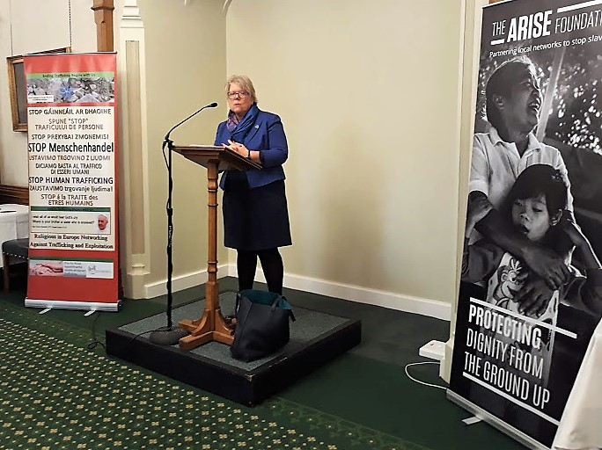
There were two purposes to the reception. First, to help close the gap between frontline antislavery groups throughout Europe and lawmakers by bringing the two together. Second, to launch new research commissioned by RENATE Europe, undertaken by Revd Dr Carrie Pemberton Ford, Director, Cambridge Centre for Applied Research in Human Trafficking (CCARHT) and Research Associate with the Centre for Global Migration (Institute of Criminology, University of Cambridge), with assistance from desk-researchers and RENATE members in the field. (www.ccarht.org and carrie@ccarht.org ).
Revd Dr Carrie Pemberton Ford
The researchers behind the report undertook painstaking work in seven European countries (Albania, Hungary, Italy, Malta, Slovakia, The Netherlands and Ukraine), setting out to document and analyse responses to the problem of child trafficking. Its findings are a wake- up call. The report authors conclude:
“…in none of the countries studied were the measures of protection comprehensively adequate to the special needs of unaccompanied minor migrants.’’
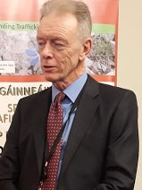
Lord Hogan-Howe, trustee of anti-slavery charity and co-sponsor of the event, the Arise Foundation said:
“I am delighted to play a part in bringing the voice of frontline anti-slavery activists to parliament. Westminster can be a bubble, and this often brings about a disconnect between what is happening on the ground and what policy-makers are discussing. Modern slave traders are organised criminals. They quickly and cleverly adapt their methods. We need frontline intelligence on the true picture of what slavery looks like, not just for our benefit, but to raise awareness among the general public who often feel far removed from the world of slavery, but in reality, are not. I commend the superb work of RENATE in bringing this invaluable knowledge to the fore.”

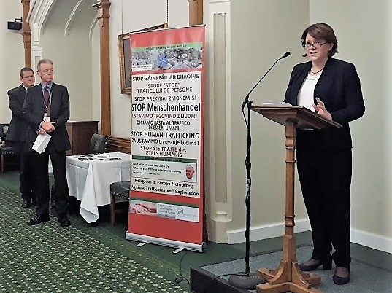
Mrs. Maria Miller, gave an overview of the review of the Modern Slavery Act and her commitment to continued provision of legislation in order to combat and end the crime of Human Trafficking. RENATE members were particularly affirmed and encouraged by her statement that ‘’You only really tackle the complex problems associated with Modern Slavery, by working with organisations such as RENATE. You are an encouragement to us all.’’
Mrs. Maria Miller, MP.
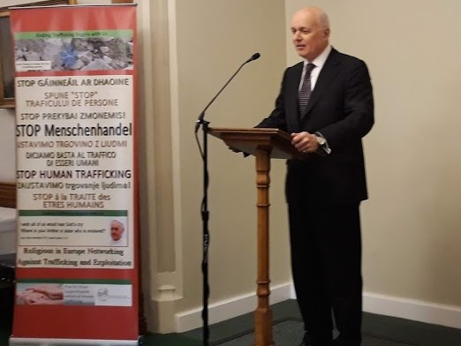
Mr. Iain Duncan smith, MP.
Mr. Iain Duncan Smith spoke about the complexity of the issue of Human Trafficking and commended the RENATE network for placing a spotlight on the issue and its outstanding work in the field.

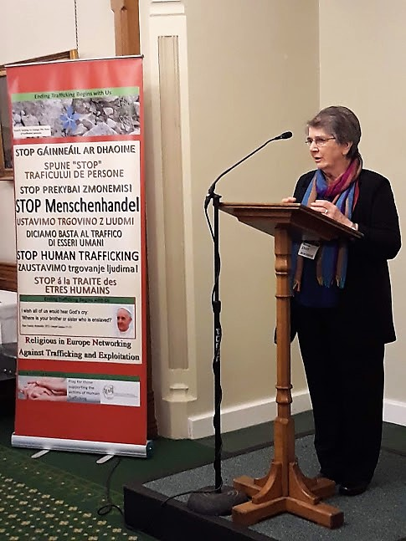
Sr Imelda Poole, IBVM, MBE, founding member of RENATE said:
‘’The next step is to translate the findings from the report into concrete policy recommendations. It is hoped that this mapping of child trafficking will lead to more action on the part of all the specialists in the field. RENATE calls on them to work more closely together, to have a desire to hear the reality, to listen for deeper understanding and with compassion. Only then when it hurts, will change, based on justice, take place. The aim of RENATE, as with the SDGs and Pope Francis in Rome, is to ‘Rid the World of Human Trafficking by 2030’. Let us unite to achieve this goal.’’

Photo gallery available at:

Prepared by Anne Kelleher, RENATE Communications.

