DASATT Conference 2018- Dublin, Ireland.
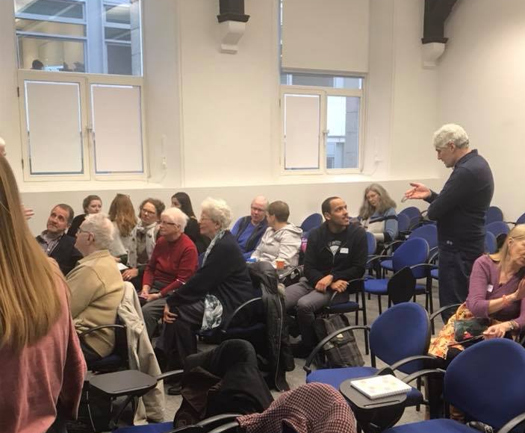
The second conference of DASATT (Development and Services Anti Trafficking Training, www.dasatt.com took place in the Loyola Institute, Trinity College on Thursday 12 April 2018. The title of the conference was “New Thinking on Human Trafficking”. It was hoped that Uachtarán na hÉireann, Michael D Higgins would address the gathering. Since this was not possible, the President’s address was read by Mr Edward Sweetman from the Office of the President. We were reminded in the address that human trafficking is a global as well as a personal matter. An tUachtarán showed that he had a wide knowledge of anti-human trafficking work and had visited Viet Nam in recent months.
Dr Gillian Wylie of the Loyola Institute,( www.tcd.ie/ise/staff ) who was hosting the conference, spoke on the legislation against human trafficking and the international politics of human trafficking. Among the neglected aspects , Dr Wylie mentioned sexual exploitation and organised crime; the historical association of trafficking and prostitution ; the focus of transnational feminist activism; gendered assumptions about victimhood and agency; early feminists and the white slave trade. The Palermo document includes the phrase “especially women and children”. It is assumed that women are the victims and men are the traffickers. In smuggling, men are victims. Many of them pay to be taken to another country. Dr Wylie asserts that there is a myopic understanding of the situation. She used the term, “carcelar(?) law”. What is happening is that we are applying crime-control approaches to complex social problems, a legalistic solution to a global problem.
GRETA is now dealing with labour exploitation – agriculture, fishing and restaurant work. Labour exploitation does not attract as much attention as sexual exploitation. Exclusionary migration policies contribute to vulnerability to labour trafficking.
What is needed is a holistic approach to human trafficking.
Economics created by structures drive people into the arms of traffickers. We need to look at the political economy behind slavery, drugs and trafficking.
Commenting on Dr Wylie’s remarks, Fr Seán Cassin OFM, Founder and CEO of DASATT, linked trafficking and development in Viet Nam, where development comes at a huge cost.
-The local population cannot cope with massive tourism.
- Giant cartels come in from China and engage in activities very harmful to the land e.g. bauxite mining, which produces quantities of red mud, destroying the land. Chemicals are running into the rivers and sea and killing fish. Deprived of their livelihood, local farmers and fishermen are vulnerable to trafficking.
…………………………………………………………………………………………………………………………………………………………………
Klara Skrivankova, UK and European Manager and Senior Private Sector Advisor at Anti-Slavery International, (www.antislavery.org ) deplored the fact that, in the UK, when a cannabis grow-house is discovered, the worker on the site is arrested and imprisoned, despite the fact that he or she has been found in a building that is locked from the outside. The real culprits, the traffickers, are not to be found. This is a clear case of legislation being an inadequate response to a trafficking situation.
………………………………………………………………………………………………………………………………………………………..
Jane O’Connell, Legal Officer with Migrant Rights Centre Ireland ( www.mrci.ie ) told the conference participants about her work with victims of exploitation by labour. Migrants Rights is located at 26 North Great Georges Street, Dublin 1.
………………………………………………………………………………………………………………………………………………………
Mike Browsowski, CEO of Blue Dragon Children’s Foundation, Viet Nam, ( www.bluedragon.org ) amazed those present by describing his work with street children, disabled children and trafficked children in Viet Nam. An Australian national, Mike has been able to rescue many children from slave labour in factories, bring home children trafficked into China, educate children and train numbers of people to combat trafficking. The project is now a multi-million dollar concern. Mike has been able to take parents into factories and even to China to see the conditions under which their children are living. Blue Dragon receives support from the Vietnamese Police Departments. He and his colleagues are involved in training programmes in Viet Nam. He contrasted awareness-raising with training, maintaining that training has a more lasting effect than awareness-raising. Ideally, when anti trafficking is successful, this will be the situation:
Families will no longer be poor and needy. Factories will no longer need child labourers. Traffickers will be disincentified. The general public will say, “This is not acceptable”.
………………………………………………………………………………………………………………………………………………………………..
Eilis Coe, rsm.
APT Member.

